2024-2025 School Supply List

**JUNIOR’S /OLDER JUNIOR’S /PRE-K**

Side walk chalk (1pk)

Washable makers (1box)

Play-dough (1pk)

Dry erase markers (1pk)

Colored pencils (1pk)

Box of tissues (1)

Shaving cream (1 can)

***Mystery*** art supply of your choice (1)

Such as..

Foam stickers

Gems

Beads

Google eyes

Coloring books

Clorox wipes-**Girls**

Gallon Ziplock bags-**Boys**

*Please bring an extra change of clothes and a 4x6 family photo on Aug. 12th

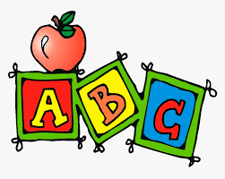

**ONE’S & TWO’S**

Smock for Art & Messy Lunches

***For the Smock please bring a **large t-shirt** for your child to wear as a smock, one or two sizes larger than your child.

(These work much better then those cute art smocks with the ties)

2 Bottles of white or clear Elmer’s glue

1 pack of Glue Sticks

Large or Extra Large Googly eyes

**Mystery** art supply of your choice

Such as…

Foam Stickers

Gems

Pom-Poms

&

Clorox Wipes

