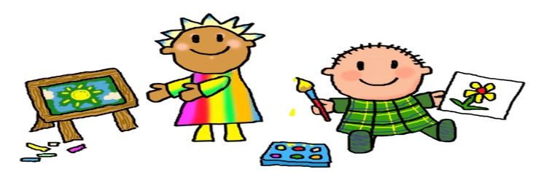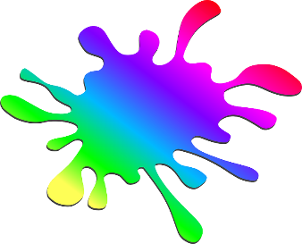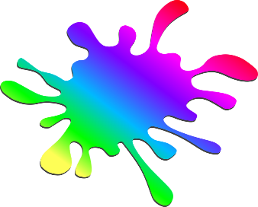

This will be a very exciting week of sensory exploration. Sensory bins will be full of new and exciting textures. We’ll enjoy group work as we sort various objects such as pom poms, feathers and paper shapes to mosaic colorful circles for our class to enjoy. Squishy play dough will be enjoyed one day and then a gooey dough the next. Our art room will be a messy good time as we exercise fine motor skills to squeeze our colorful glue. We’ll create a swirl of colors as we marble paint our new number 3 with balls.

Many fun counting activities will help us to understand our numbers 1,2 and 3. We’ll be counting squishy tall towers as we stack foam blocks with shaving cream at the tables. Color and shape songs will be enjoyed this week as a review along with a new counting song. Rhythm sticks will help us practice using our listening ears during music time. Dancing with colorful scarves and egg shakers will get all of our little friends up and moving. They are also really enjoying counting to 3 with our pop the bubble song. Bubbles always bring a smile to our little faces.

[This Photo](http://learningwithmrsparker.blogspot.com/2013/07/creation-station.html) by Unknown Author is licensed under [CC BY-NC-ND](https://creativecommons.org/licenses/by-nc-nd/3.0/)

**Toddler News**

Feb. 5-9 Week 26

Theme: SQUISH, SPLASH, SPLAT

Introduce: #3