banner with apples and crayons

**Miss Milham’s**

**Kindergarten & Accelerated Pre K**

**All-star News**

**August 2, 2019**

This week, we will continue to learn about the **Five** **Senses**, focusing on the sense of touch, taste and smell.

**Sight Words**

String, Bean, How, you, do, Banana, Peel, And,am

**Expressive Vocabulary**

**Abrupt:** *without warning, sudden*

**Brilliant:** *sparkling, glowing; very bright*

**Manners** “Please” and “Thank you”

**Featured Story “**The Kissing Hand”

**Bit Cards** MusicalInstruments

A little “bit” of information will be introduced about different instruments.

**Reminders**

* Labor Day-center closed.
* Don’t forget to sign up to receive important information regarding our center on the REMIND App.

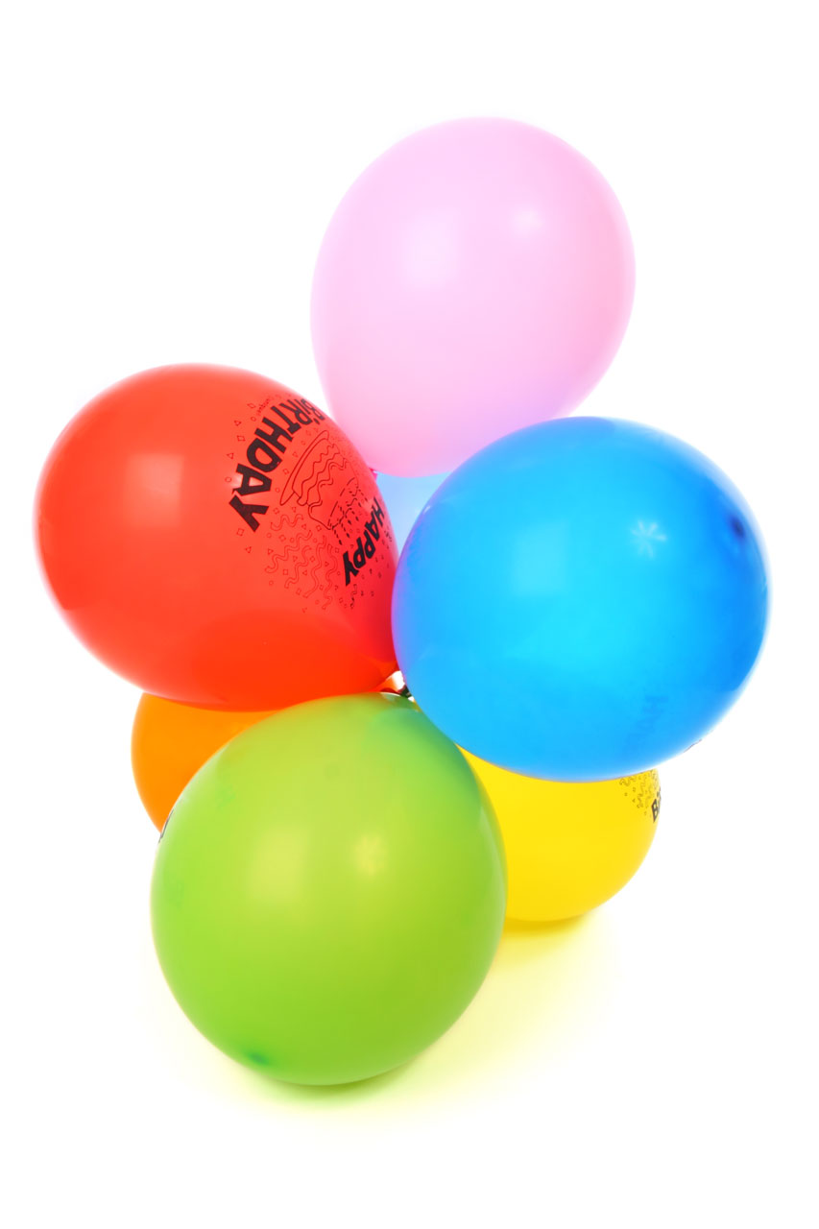**HAPPY BIRTHDAY**

**Zachary** **Ejsmont 9/1**

**Josiah McDonald 9/1**

**Jocelyn Givens 9/6**

# Craft an Writing

The children will practice printing the letters Ee and Ff when working on their phonics papers. During craft time, the children will make a Five Senses Mrs. Potato Head craft.

# Math, Science & Social Studies

In Math, the children will learn the shapes *rhombus, half circle,* and *trapezoid.* We will explore how to make an AB pattern.

In Science, the children will be doing experiments related to the sense of taste, smell and hearing.

# Accelerated Pre K News

**Introductions:**

**Letters**: Ee & Ff

**Numbers:** 5 & 6

**Shapes**: Rhombus & Pentagon

**Reading Story**: String Bean

**Reading Words**: Come, jump, String, Bean and

# Language Arts/Phonics

Our focus this week is our letters Ee and Ff. The children will learn that the letter E is a vowel and that it makes a long and short vowel sound. Rhyming words will also be introduced this year. These are words that sound alike and have the same ending in the word. For example, cat/hat or house/mouse.