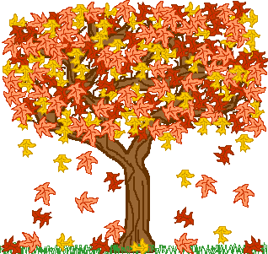**Nursery News**

**THEME: Fall**

In the second week focusing on the season of *Fall,* we will further our discussions about the changes we notice in the weather and the leaves on the trees.

**Mrs. Desi, Mrs. Taghrid, Ms. Melissa and Miss Riley**





**Student of the Week**

Emerson Kornfeind

Ava Smith

**Language Arts:** The children will enjoy the flannel board story *Trees.* Our listening activity involves following the directions to the finger play “I’ll Touch My Hair” and “5 Furry Squirrels”. The children will love learning about the alphabet beginning with our new letters “A” and “B”, as we introduce the “A is for Amos” song. This song teaches the children about the different sounds each letter makes.

**Concept:** We will add number counting concepts and our new letters to our shelves and play the bug splat game. Long and short will also be part of our lesson this week. A fall sensory bin will keep us interested in learning about our new season.

**Craft & Writing:** We will be creating some fun fall crafts with leaves, and color letters A and B. Painting with yellow and green will be a fun and we will wrap and learning up this fun week with a beautiful fall scene art piece we have working on to display in our

classroom.

**Motor:** The children will practice kicking balls at the target and sing songs while I the rocking boat. As always, if weather permits, outside time is a must!!

**Upcoming Events**

October 10-Columbus Day-center closed

October 25 & 25-Picture Day (info to follow)

October 27 & 28-Halloween Parties