Miss Milham’s Kindergarten News

October 10-21, 2022

**Theme: Spiders and Bats**

Who’s afraid of spiders and bats? We will find out as we make a graph in class this week.

**“50” Days of School!**

Can you believe we will be celebrating our 50th day of school already?

Don’t forget to dress up ***50’s*** style on Tuesday, October 25.

Have a great week!

# Craft and Writing

This week, the children will work on phonics papers and practice printing/tracing our new letters. They will learn about the different body parts of bats and spiders by labeling them and creating a booklet about them.

# Math & Science

In Math, the children will learn about the geometric shapes *rectangular prism, and triangular prism.*

In Science class, we will learn that bats fly at night, sleep upside down, and eat 1000 mosquitoes in a single hour, and that spiders lay hundreds of eggs, spin webs, and dance.

The letters Qq, Rr, Ss, & Tt, will be introduced this week, along with their phonetic sounds. We will continue to review rhyming words, compound words, word families.

C:\Users\bncc001\AppData\Local\Microsoft\Windows\Temporary Internet Files\Content.IE5\CEFDDV0S\MC900020667[1].wmf

**Introductions**

**Letters:** Qq, Rr, Ss & Tt

**Bit Cards:** Van Gogh

**Manners:** “Don’t point at people”

“Pick up after yourself”

**Fable:** The Boy Who Cried Wolf

**Moral:** If you tell a lie, know one will

believe you.

**Important Events**

Halloween Party - October 27 & 28

Orange & Black Day – October 31

Are you receiving alerts on the **REMIND** app?

Go to **rmd.at/theilma** on your smartphone to download the app.

# Language Arts

Party

**Ranger of the Week**

**Liv Forlenzo**

 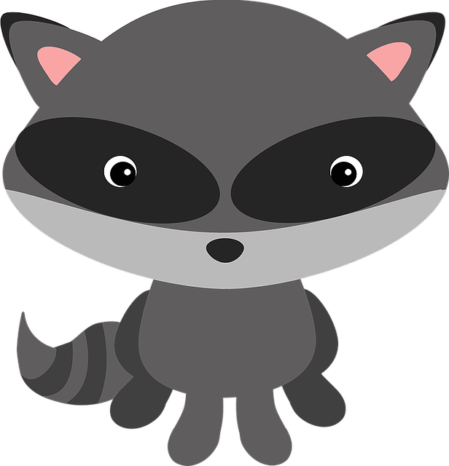

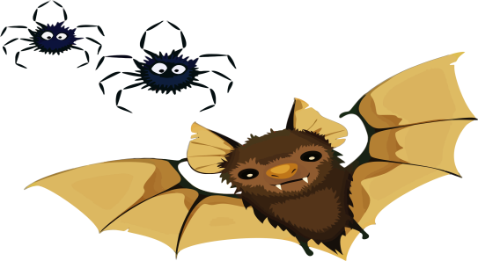

**HAPPY BIRTHDAY!**

Matthew Lehman 10/17

Kylie Donnelly 10/18

