* 

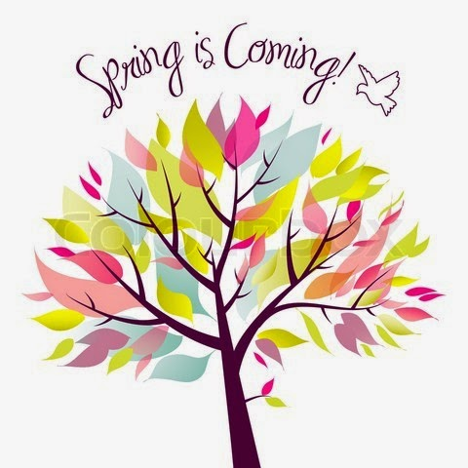

 



Each student is asked to bring or wear a

Baseball hat for Parent’s Day surprise.

Please let us know if you will **NOT** be

attending Parent’s Day.

If you will be sending treats for Easter Party

Mrs. Jackie’s class has 9 students and Mrs.

Peggy’s has 8 students.

We are discussing reptiles, ocean animals and spring over the next several weeks.

Our Easter Parade will be on Wednesday, March 21st at 9:15am. Each student should wear an “Easter Hat”. We will parade down to the firehouse and back (weather permitting). You can park on 167th to cheer us on.

We are busy preparing for Parent’s Day on Saturday, March 24th, at 10:00am. We would like each student to bring bring/wear a **baseball style cap** for Parents’ Day. Please let us know if your child is **not** able to attend. We can’t wait to show all our parents how we spend a “typical” school day. I am sure you will enjoy.

**REMINDERS**

**Focus**

**Theme-**

**Reptiles, Oceans, and Spring**

**Language Arts-**  We will introduce story #11and the words associated with “My Blue Boat”. These words will be added to the word wall, My/my, Blue/blue, and Boat/boat. We will continue to work on all previous stories and words.

**Motor**- We will hopefully be able to enjoy some outdoor play as well as the ball and wand.

**Craft and Writing –** We will be doing some readiness papers for ocean animals and spring. We will continue reviewing numbers 1 - 20 and continue working on a special project for parent’s day.

**Concept**- This week in math we will be using patterns. We will work on number concept with our Easter eggs. In science, we will begin to talk about different types of weather and how it affects us and our new season of spring.

**Week 31 & 32**

March 16th – Wearing of the Green

March 21st – Easter Parade 9:15am

10:30am Easter Party

March 24th – Parents Day – 10:00am

March 26th – 30th – Spring Break – **No School**

LKING AHEAD



Mrs. Jackie & Mrs. Peggy Week #31-32 March 12 - 24, 2018

PreK Bi-Weekly

The